***AUTOPSY FORENSIC EXERCISE***

***“FORENSIC IMAGE ANALYSIS REPORT WITH AUTOPSY”***

***SUBMITTED BY ADENIKE OLUWABUSOLA ONI***

***Autopsy Forensic Software***

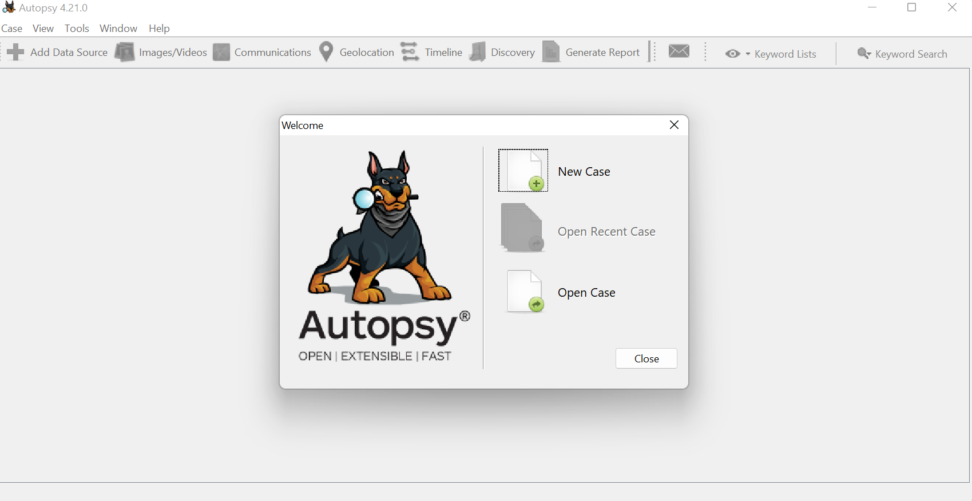

Step 1:- New case - Fill case information - Next - Fill Optional Information - Finish

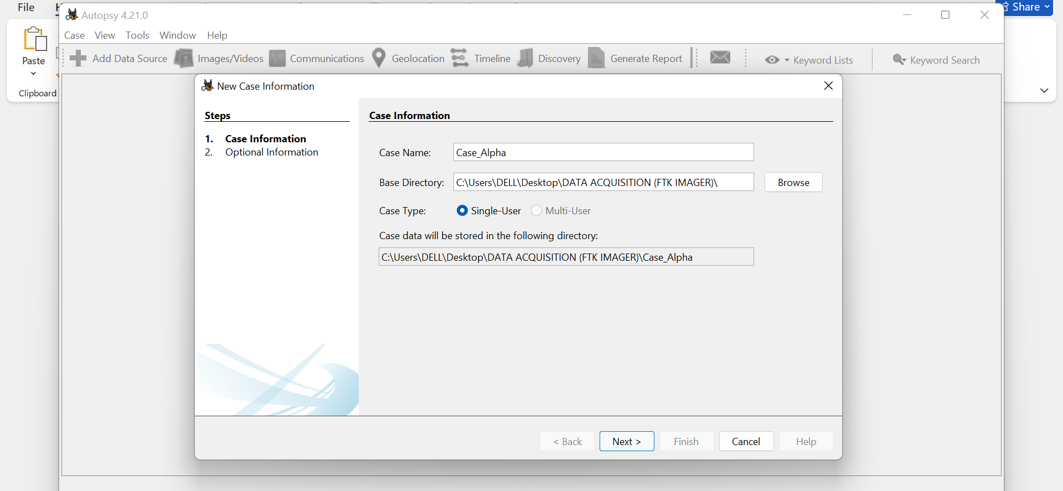

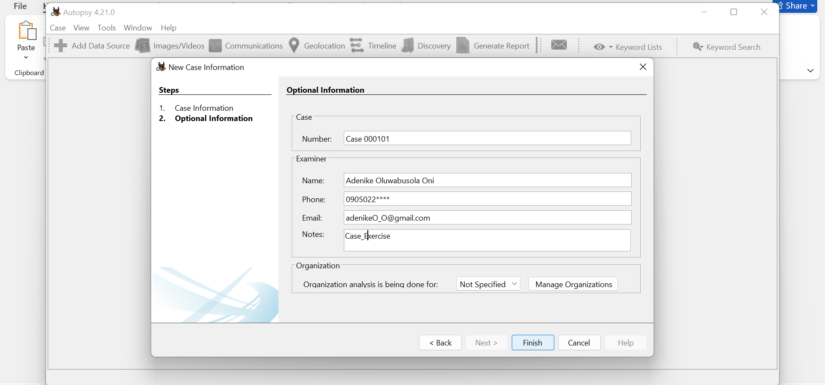

Step 2:- Select Host - Select Data Source Type - Select Data Type - Configure Ingest - Add Data Source -

Select Host - Next

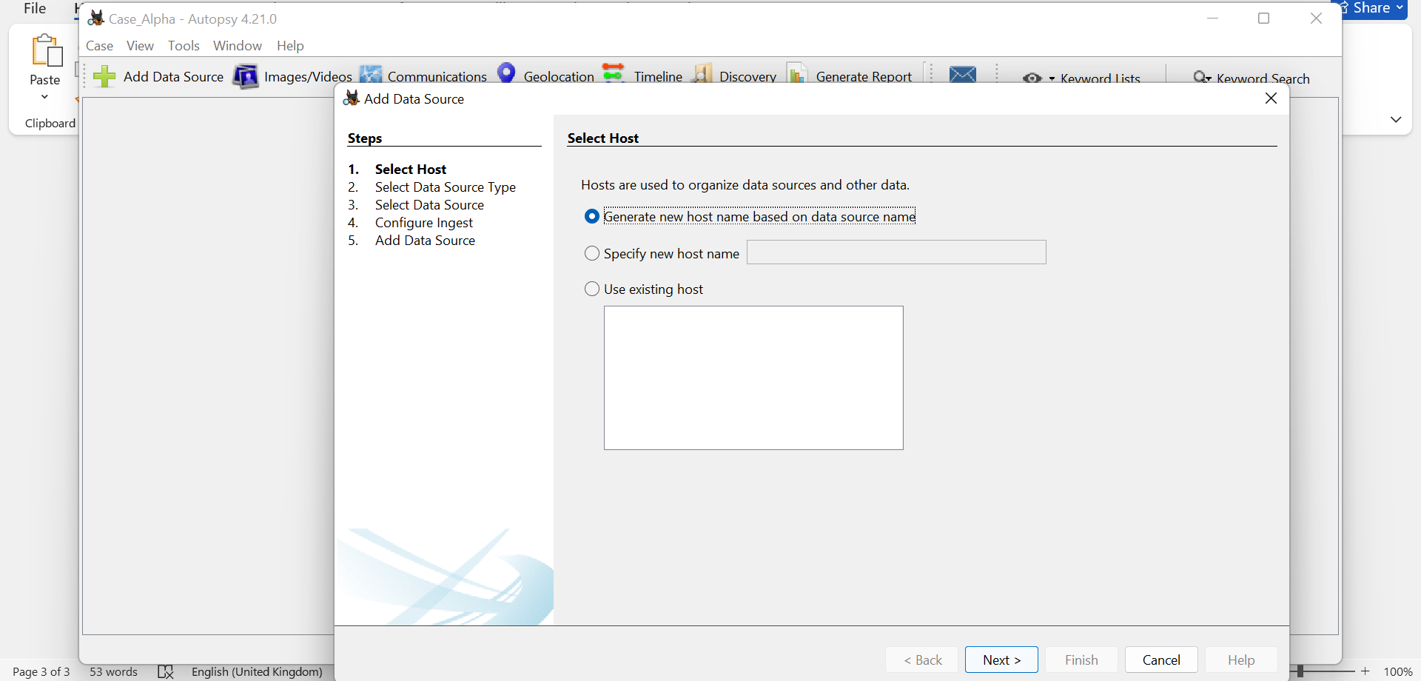

Select Data Source Type - Next

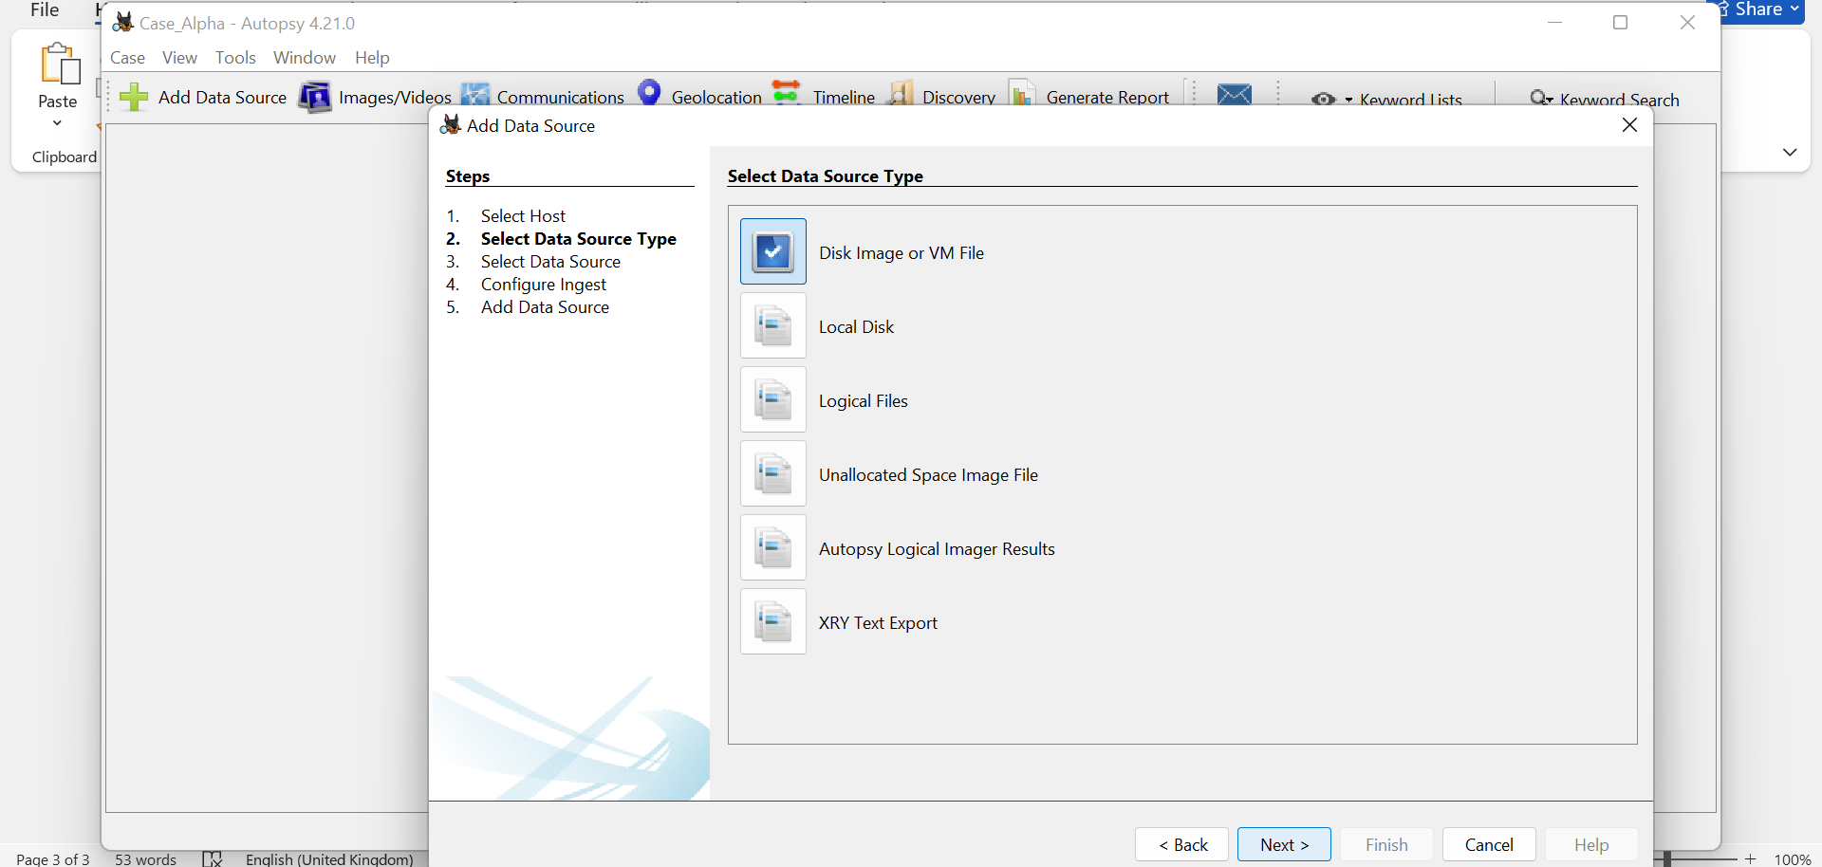

Select Data Type - Next

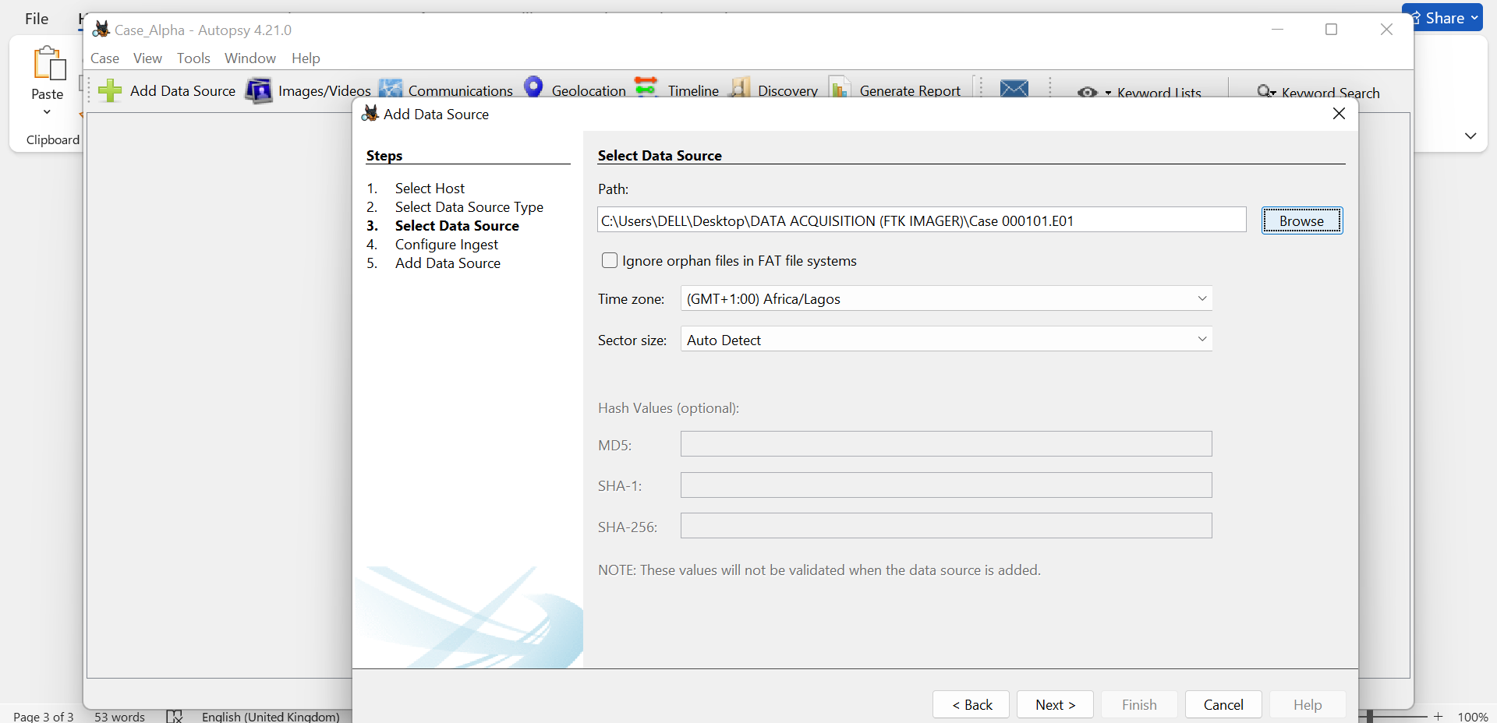

Configure Ingest - Next

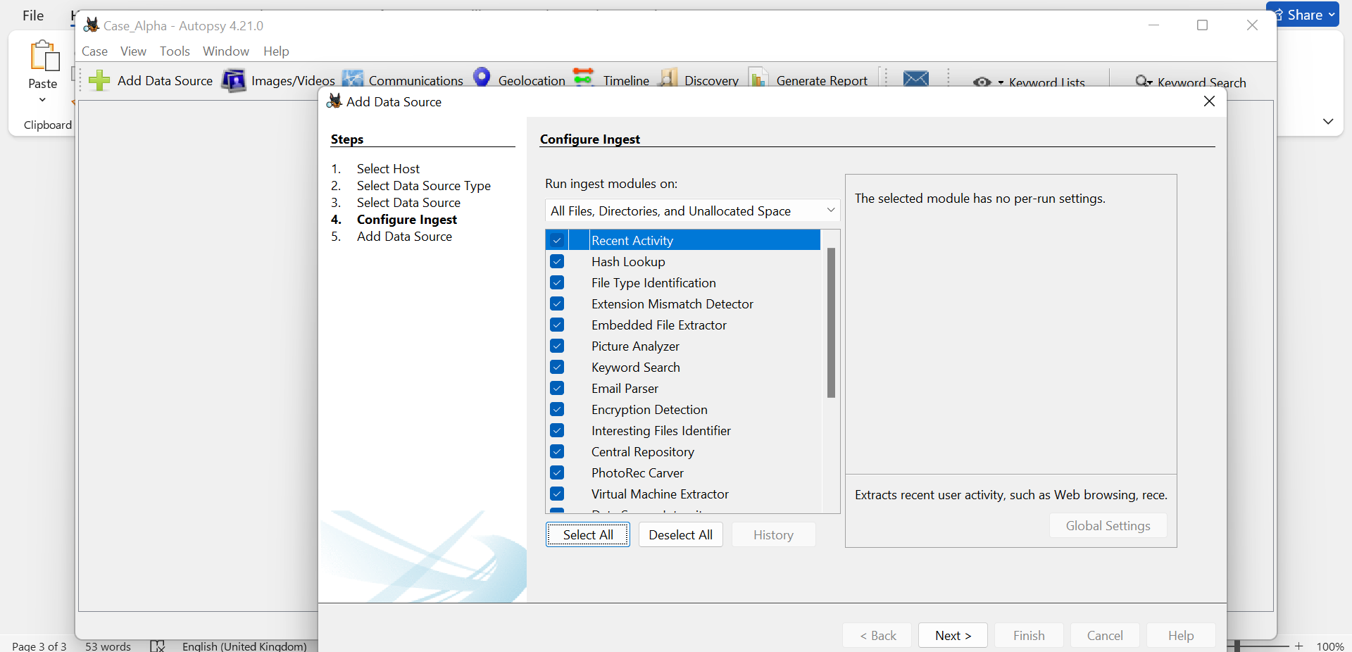

Add Data Source

Processing Data Source

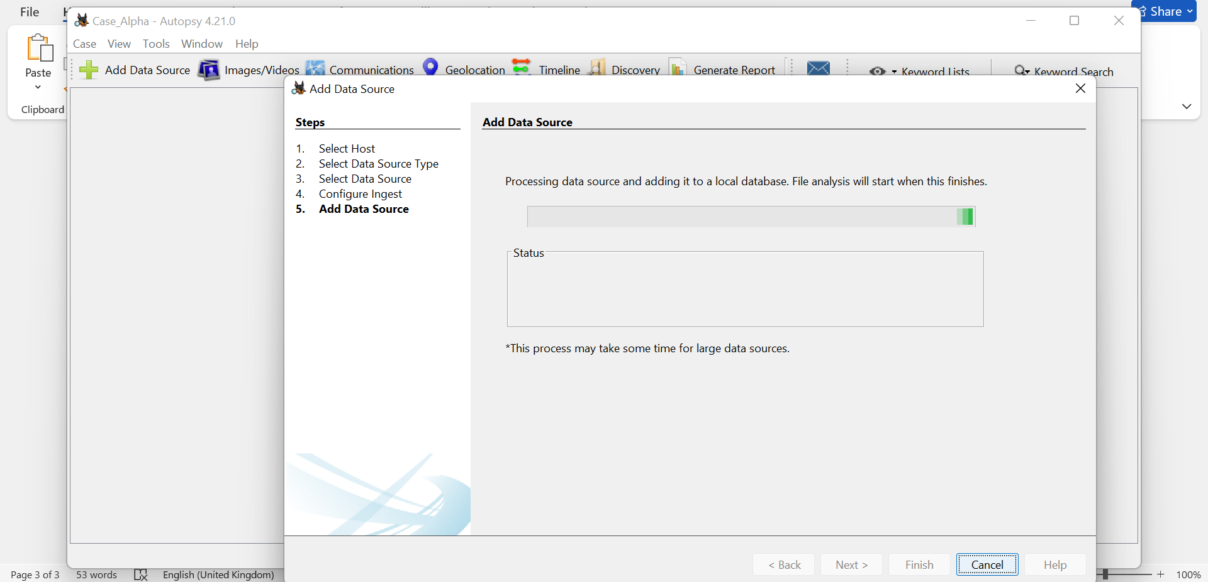

Data source added - Finish

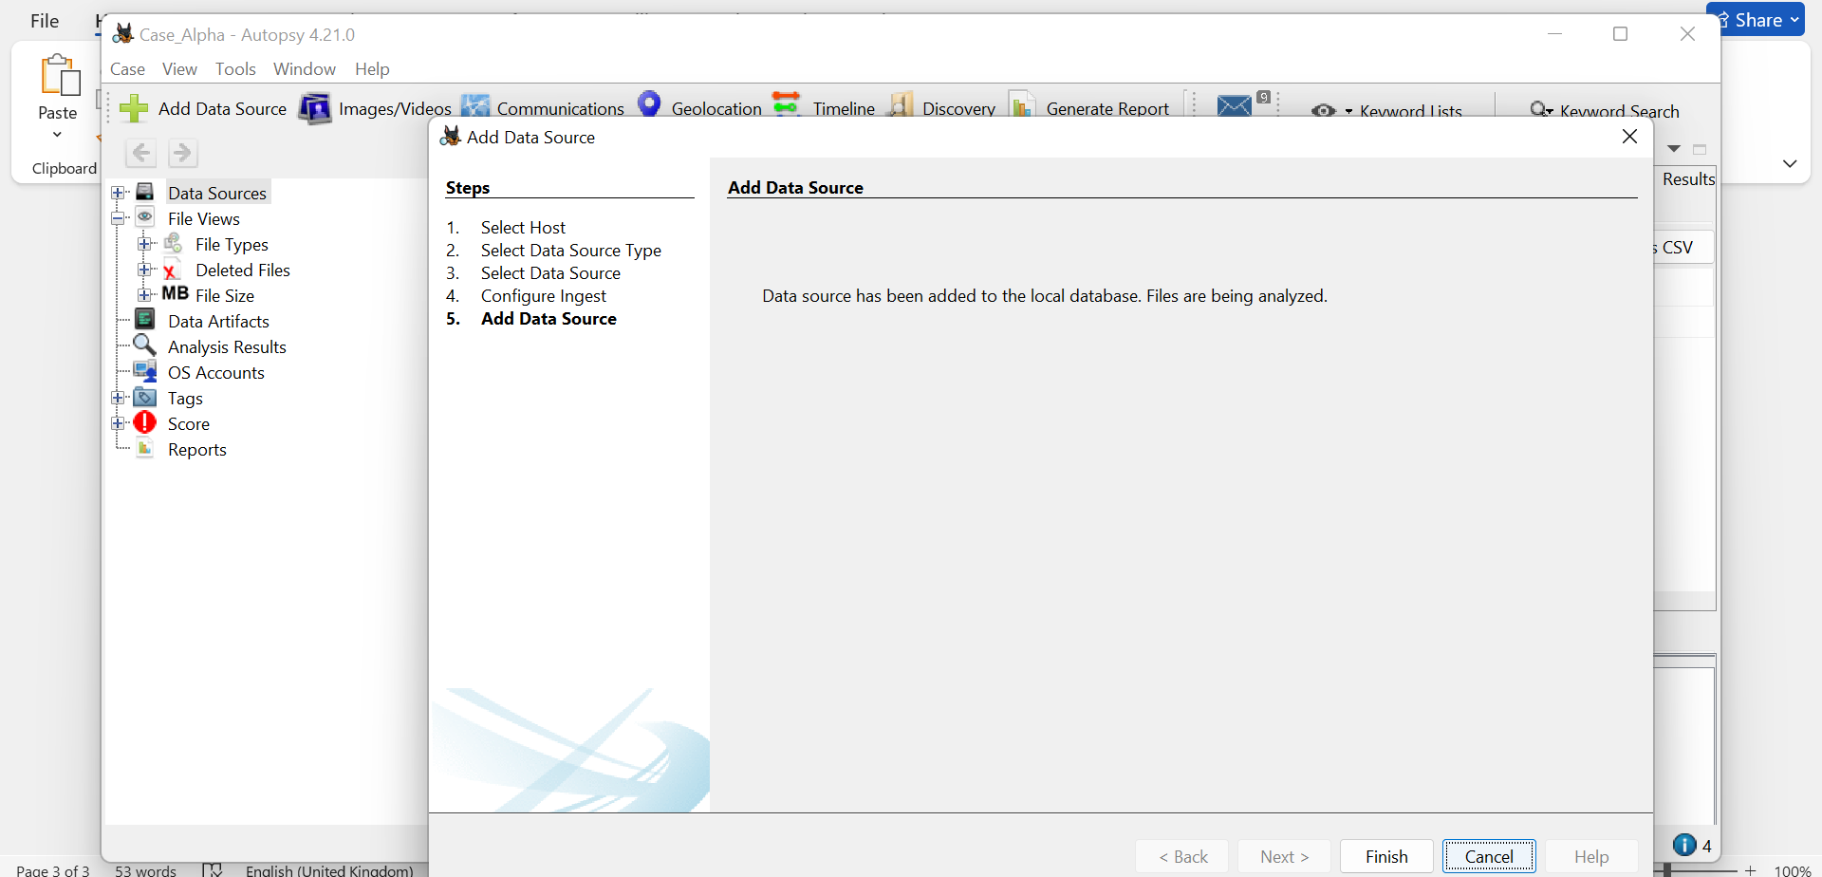

Result of Forensic Image Analysis

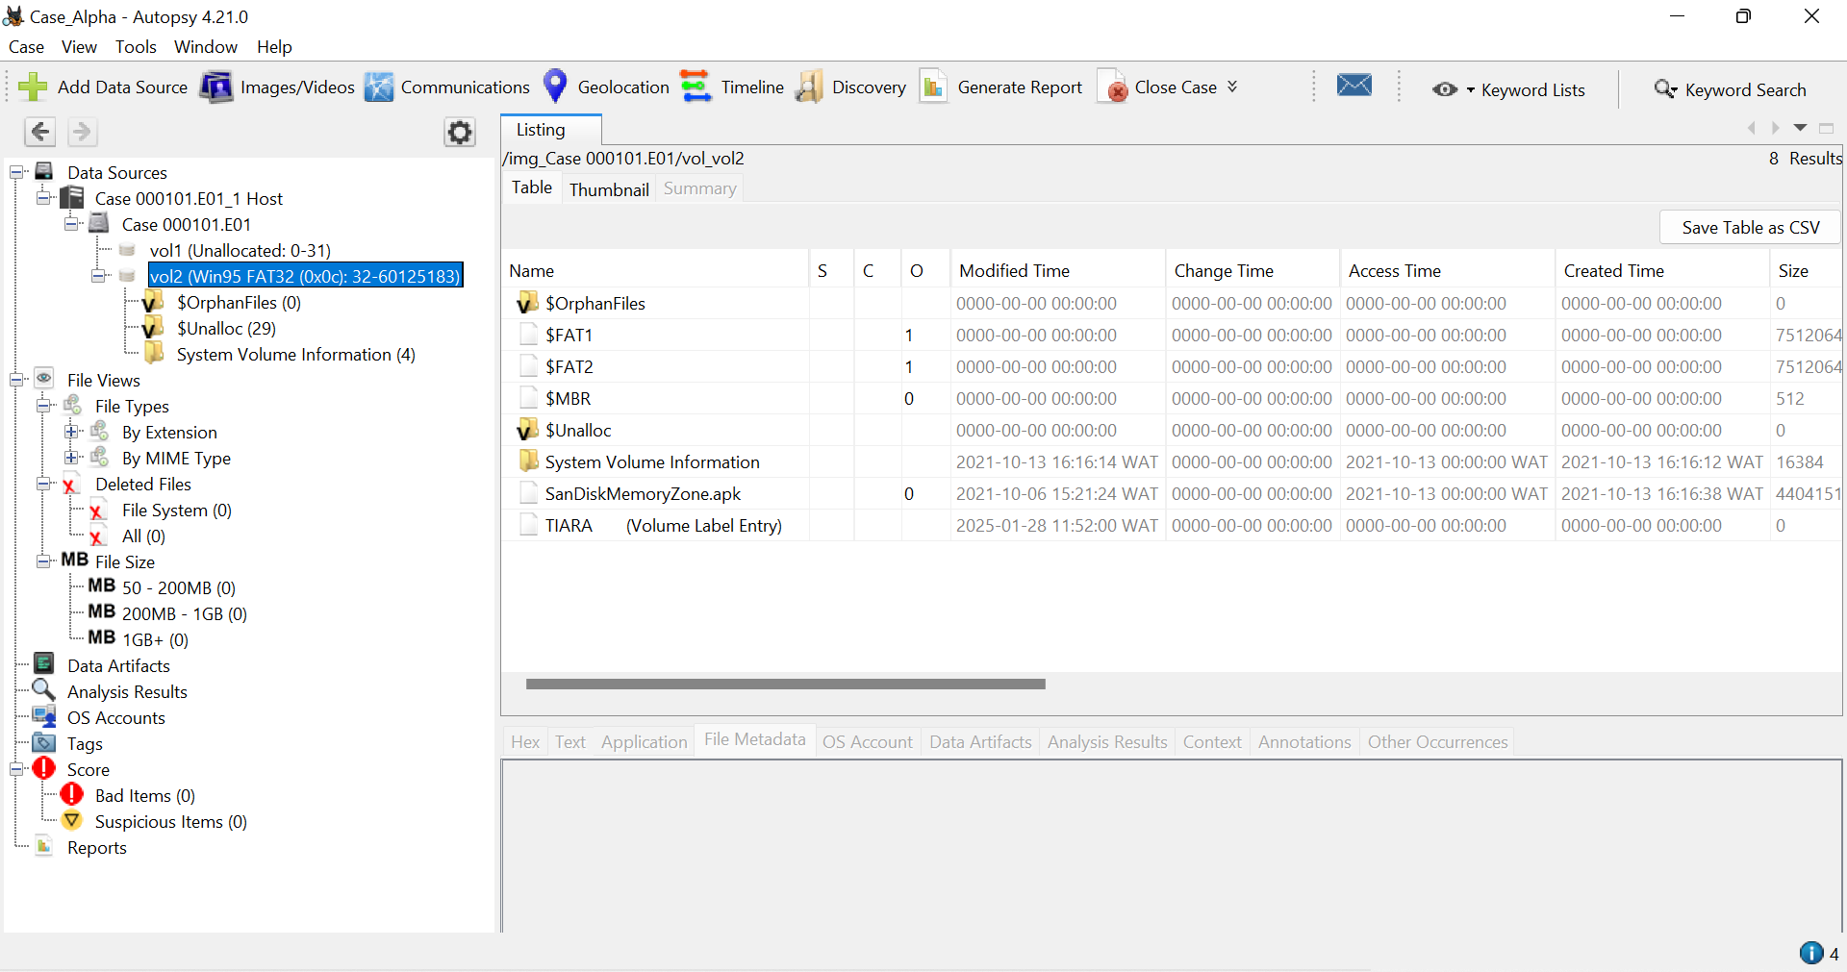

Generate Case Report - Next

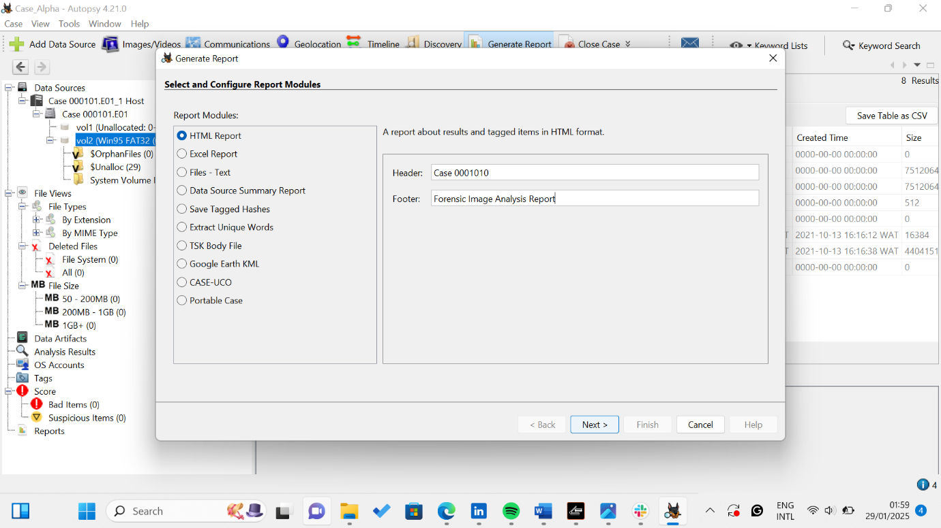

Data source to be included in the generated report - Next

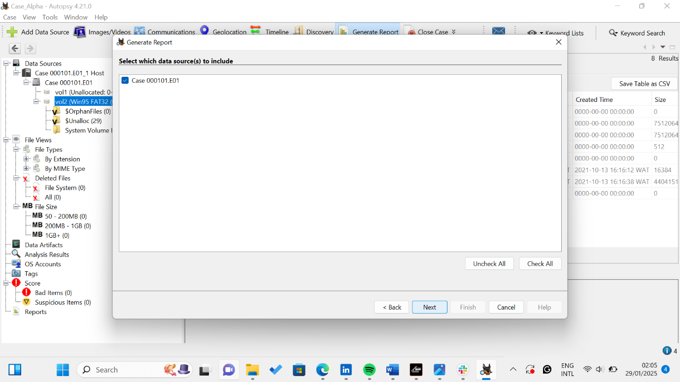

Configure Report - All Results - Finish

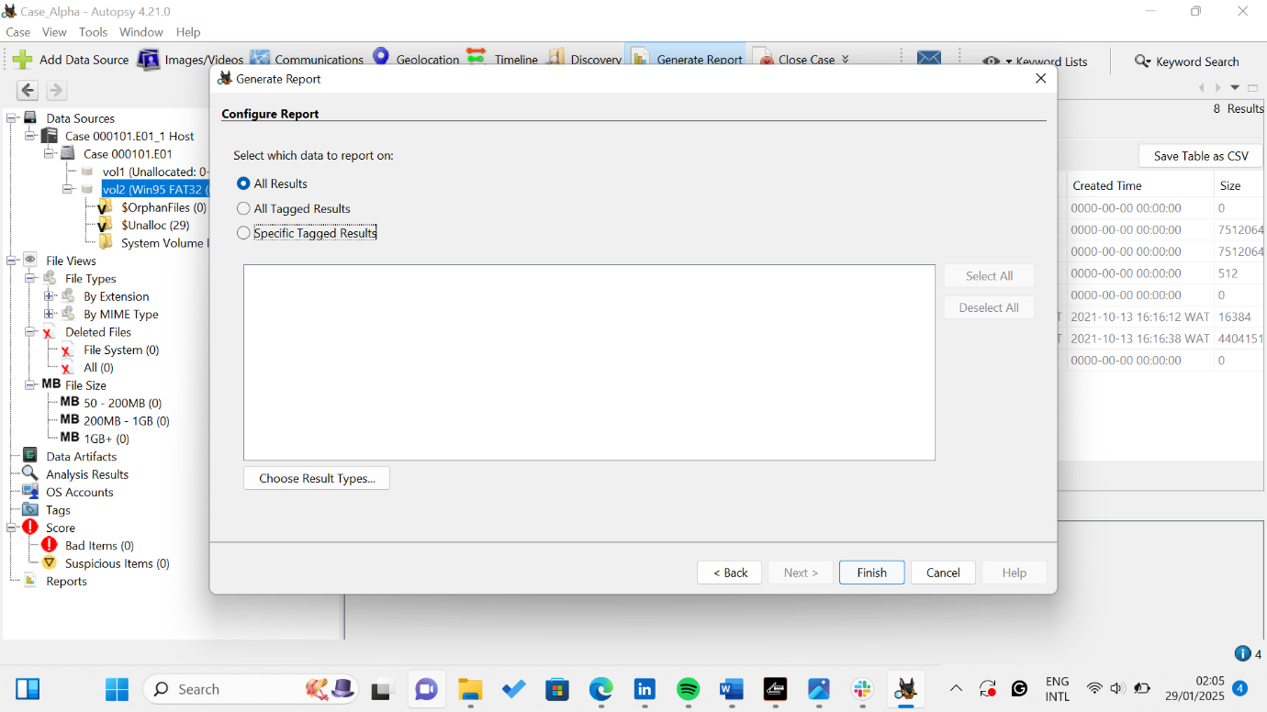

Report generation completed

(To view, click the link HTML Report)

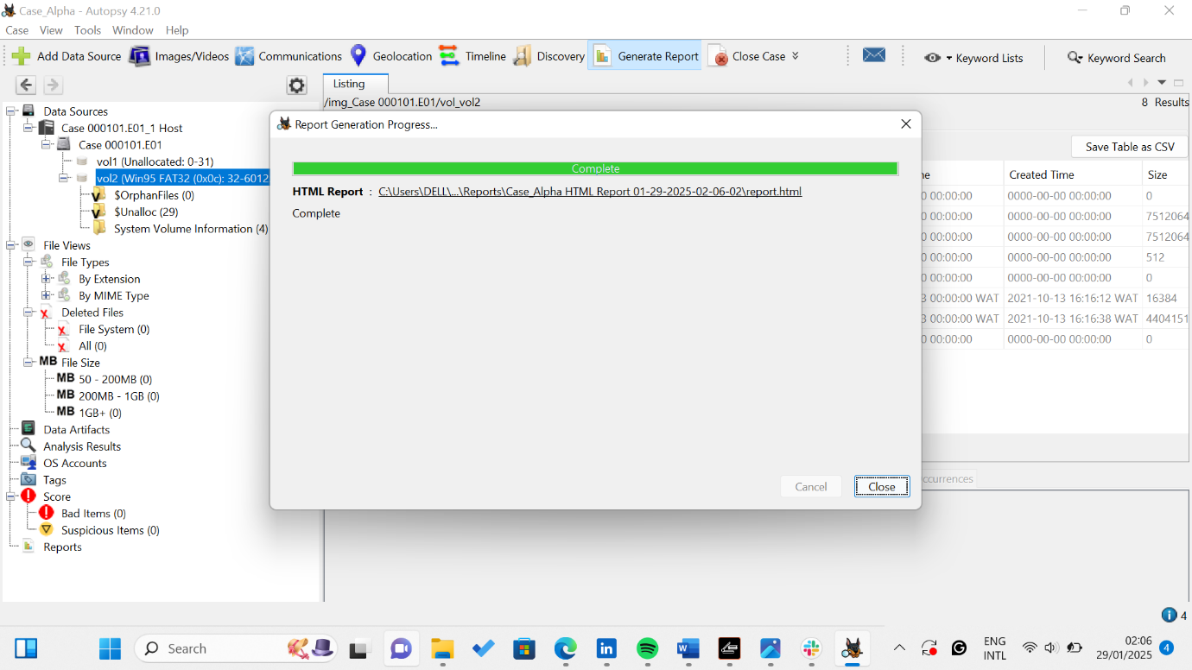

Autopsy Forensic Report

